Q1) taking a backup of ami on daily basis in interval of 12hr.

* Open aws console and go on ec2 and create instance.

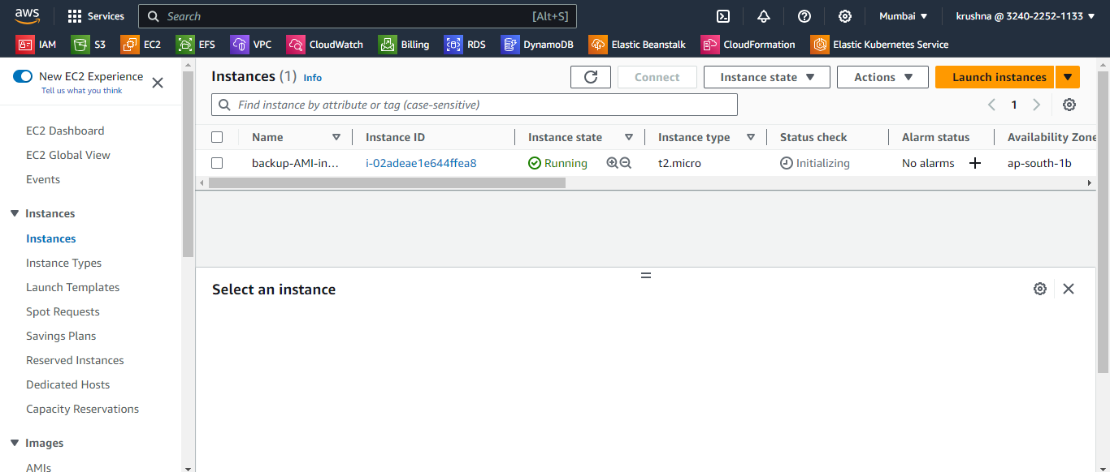

* Take access of instance and create .sh file

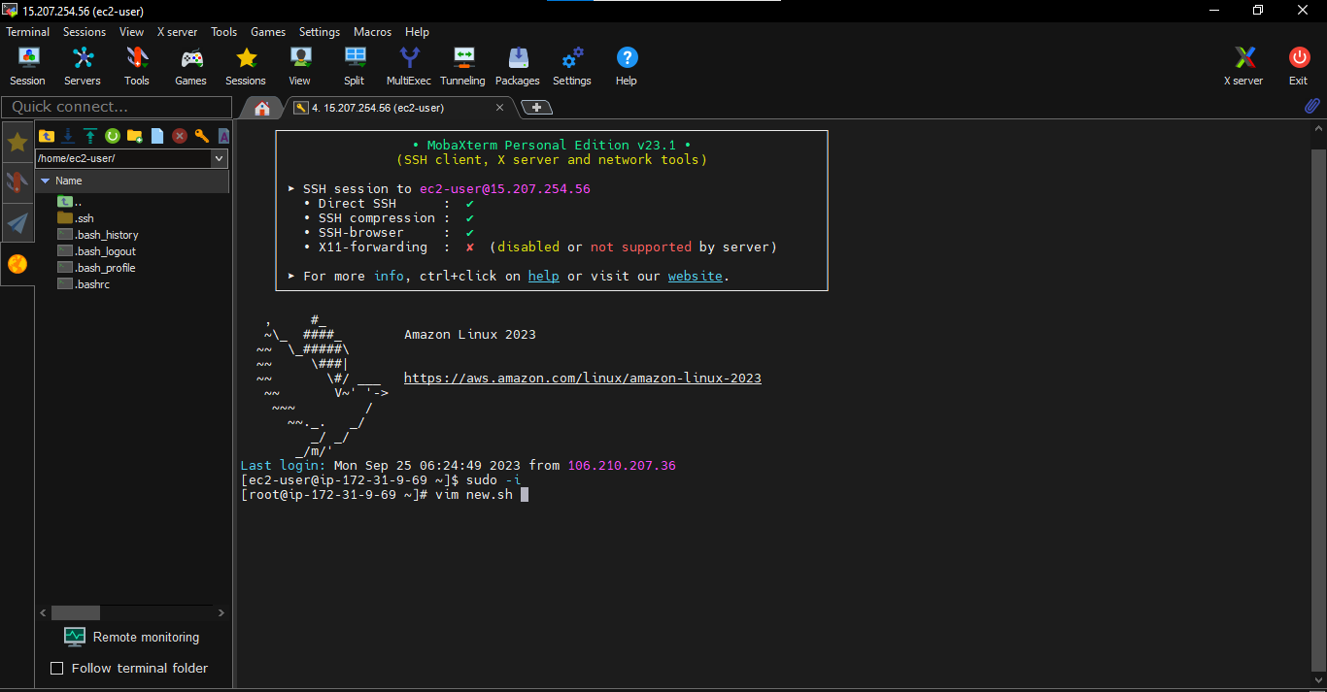

* After create .sh file write a script

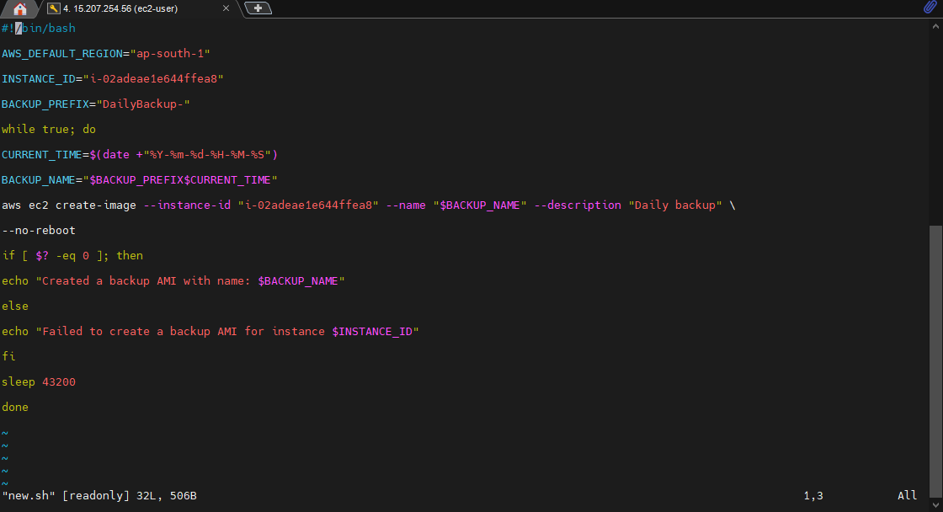

* Give a execute permission of file

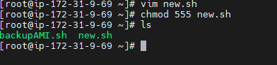

* Install crontab for schedule crontab job.

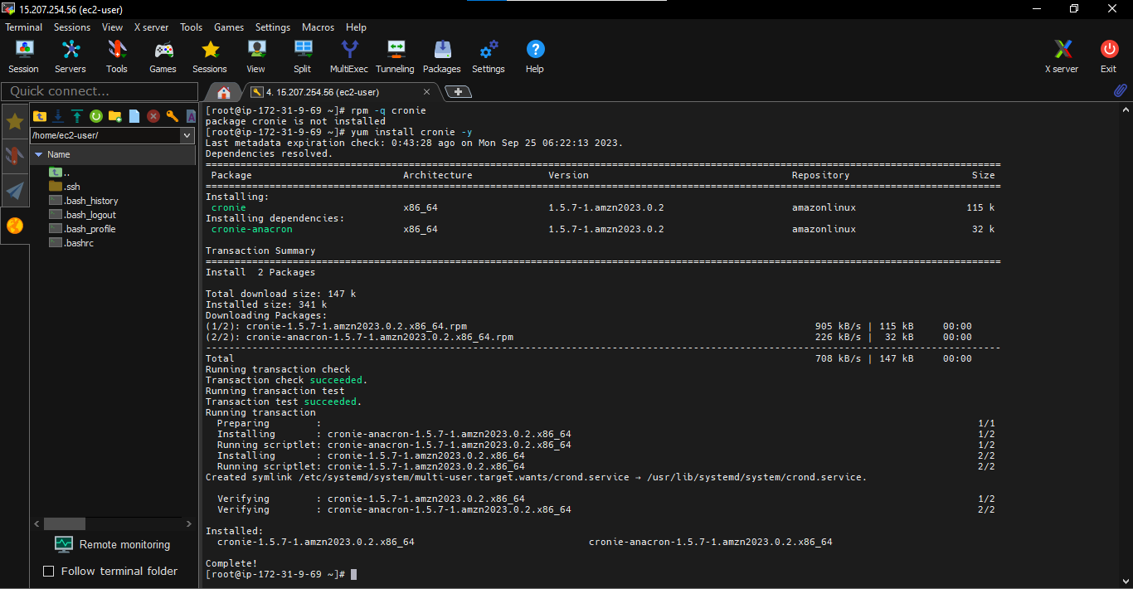

* Schedule crobtab job

